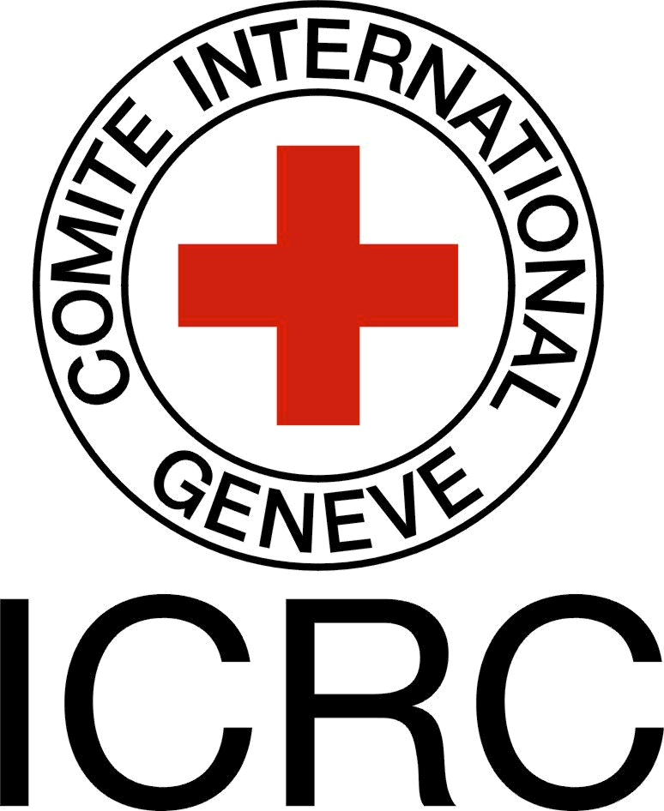
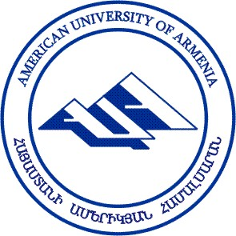

International Committee of the Red Cross
AUA LL.M. Program

International Humanitarian Law
Summer SCHOOL
6- 11 July 2015

Application Form

Personal Information

Last name and first name:____________________________________________________________________________

Address:__________________________________________________________________________________________

Phone number:_____________________________________ Mobile number: __________________________________

Email:____________________________________________________________________________________________
Education
University | Specialization | Year of graduation | Program duration

Have you participated in the Public International Law course? Yes No

If yes, please attach proof, e.g. diploma, transcript, certificate etc. If not, clearly state how your previous/current work or research is related to Public International Law or IHL.

Please send this application form to law@aua.am and ialoyan@icrc.org by 22 June 2015.

_______________________ ___________________
Signature Date

