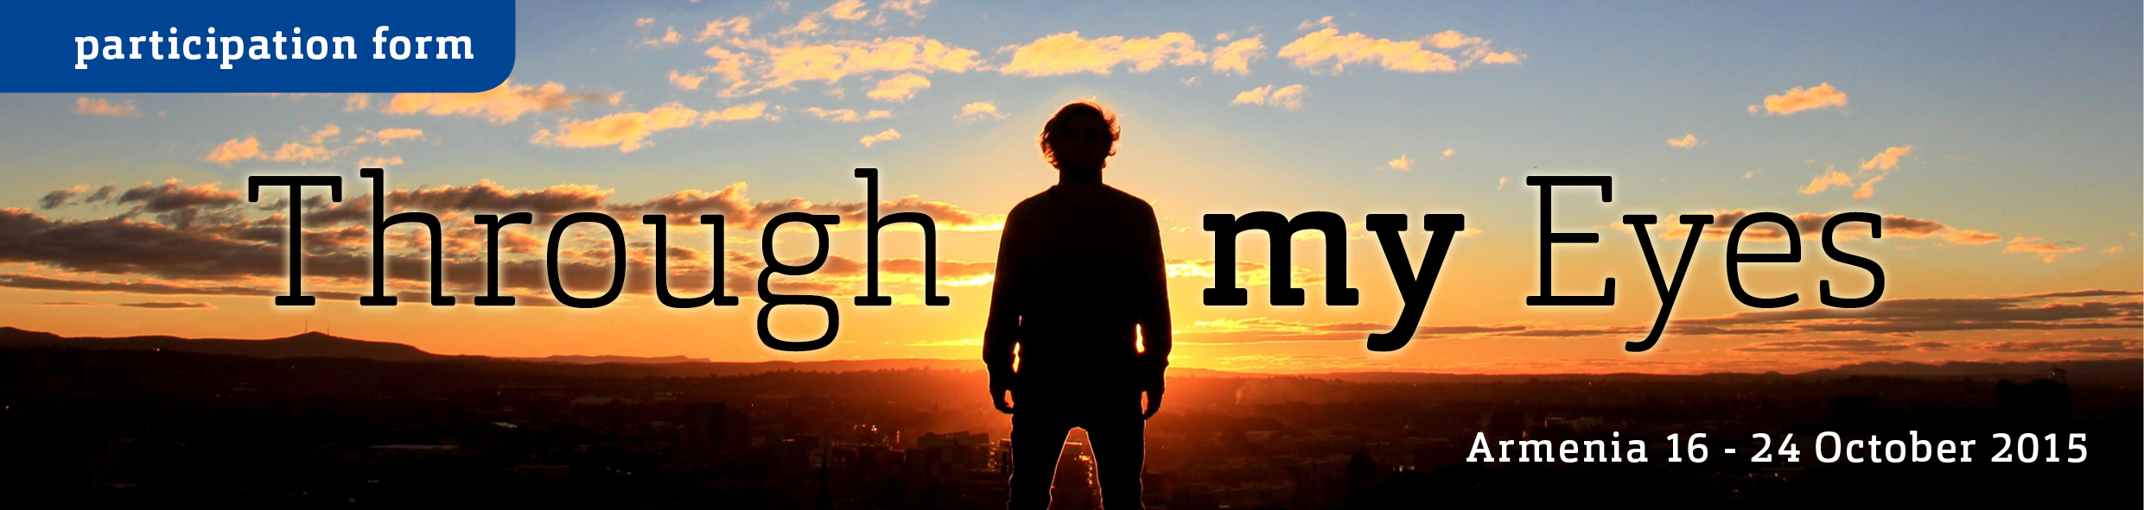



For all information about this training course, make sure you have read the ‘Call for Participants’ (pdf).

This questionnaire is so that we get know a bit about you, your background and the expectations you have for the training course. Please consider your answers carefully and answer all questions. We will collect applications until June 30th. Shortly after that you will be informed about the selection results.

If you have any questions contact us at live.n8w@gmail.com

PERONAL INFORMATION
Name & Surname
Gender
Age
Country | other:
City
Organisation
E-mail
Phone number
Facebook page | facebook.com/

Level of English (speaking)

Special needs Please indicate if you have any special needs, food allergies, mobility problems etc.

EMERGENCY CONTACT PERSON
Full name
Relation to you
Location/City
Phone number

ABOUT YOU
What do/did you study? What is your occupation?

How would you describe yourself? What are your passions / hobbies? What do you love in your life?

Describe your perfect morning, afternoon or evening.

What areas of your life are you unhappy with? (Please answer both and be specific)
Private:
Professional:

EXPERIENCE / WORKING WITH PEOPLE
In which training courses have you participated? Please describe the subject and when this was.

What experience do you have as trainer in conducting training courses for young people? National or international?

How did you get interested to work with people? (Be specific)

YOU AND THIS TRAINING COURSE
What do you want to learn or which skill(s) do you want to develop in this training course? (Be specific)

Describe (as much as possible) what you would like to accomplish out of your participation.

Afterwards, how will you use what you have learned in this training course?

How did you find out about this training course?

* I understand that by submitting this application, I confirm that the answers I filled in are true and complete. I understand that if I am selected as a participant, I will fully follow the conditions and rules established by the organizer.

* I have read and understood the rules for travel reimbursement in the ‘Call for Participants’ (pdf).

When completed, save and send this file to live.n8w@gmail.com before June 30th 2015.
Soon after that you will be contacted about selection results.

